Problems and questions:

Are the results obtained by nmap reliable?
Yes, Nmap results are generally reliable, but not always exact. Accuracy depends on network conditions, firewalls, host configuration, and scan options. Services may be misidentified or shown as open|filtered, especially with UDP or when defensive mechanisms are in place, so results should be validated with additional tools or manual checks.

Does the information obtained about the target host depend from the scanning options?
Yes. Different scan options significantly change both the amount and accuracy of information gathered. Basic scans may only reveal which ports are open, while more advanced options enable deeper analysis.
For example, -sS (SYN scan) is faster and stealthier than -sT (TCP connect scan) but may be blocked by firewalls. The -sV option enables service and version detection, while -O attempts operating system fingerprinting. Timing options (-T0 to -T5) affect scan speed and reliability, where slower scans are more accurate but take longer. Additionally, NSE scripts (-sC, --script) allow active enumeration and vulnerability detection, revealing web directories, misconfigurations, and known weaknesses that would not appear in a simple port scan.

Is it permitted to use nmap to scan hosts without permission?
No. Scanning hosts without explicit authorization is generally illegal and unethical and may violate laws, organizational policies, or terms of service.
Nmap should only be used on systems you own or have clear permission to test (such as personal labs as today or authorized penetration tests).

Property analysis of available algorithms:

Run all VM you have installed in VirtualBOX:
User and password of:
Metasploitable: msfadmin,msfadmin
Kali: stud, stud
Ubuntu: student, student

Execute the following command: > nmap 172.16.96.0/24 (WHAT IS THIS IP ADDRESS AND WHAT IS THE DIFFERNCE WITH THE ADDRESSES BELOW?)
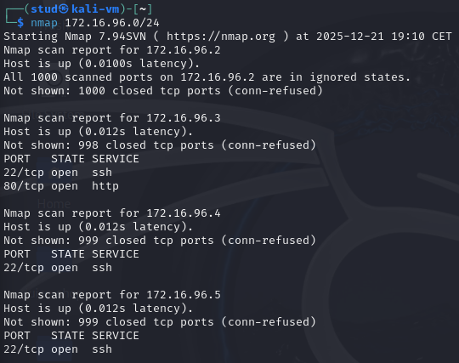
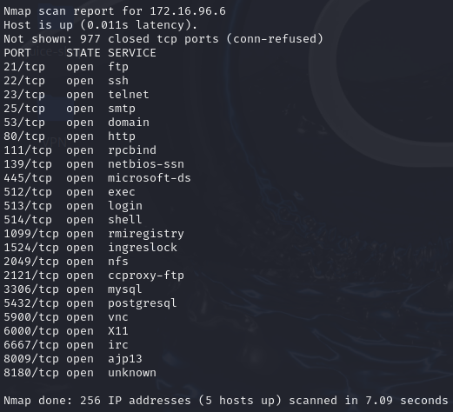
172.16.96.0/24 is the network. Scanning it returns which IPs are up and which services/ports they expose. And a single IP 172.16.96.x is a host within that network.
The command shows 5 main things:
- Active hosts in the subnet: Out of 256 possible IP addresses, 5 hosts are up: 172.16.96.2, .3, .4, .5, .6.
- Which TCP ports are open on each host (top 1000 ports): .3 → SSH (22), HTTP (80), .4 → SSH (22), .5 → SSH (22), .6 → many services (FTP, SSH, Telnet, SMTP, HTTP, SMB, databases, VNC, etc.) and .2 → no open TCP ports found in the default scan.
- Service identification by port number: Nmap maps open ports to common services (e.g. 22 → ssh, 80 → http, 3306 → mysql).
- Port states for scanned ports: Most ports are closed (conn-refused), also has open ones.
- Basic network responsiveness and scan performance: Each host shows low latency (~0.01 s) and the entire /24 network scanned in 7.09 seconds, indicating a local virtual network

Execute different types of TCP scans and compare results:
A. Options –sT, -sS –sN, -sM, -sA, -sW, -sI.
We have chosen the host of metaexploit as it has many open ports.
nmap <flag> -p 1-1000 172.16.96.6
-sT: Full TCP connect
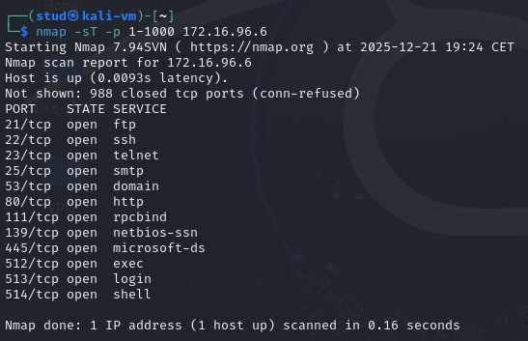
-sS: Half-open SYN (needs sudo)
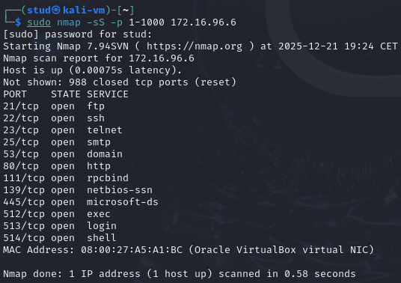
-sN: No TCP flags (needs sudo)
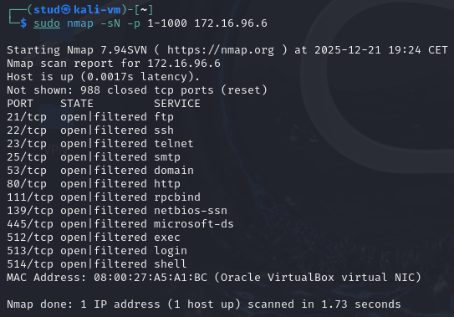
-sM: FIN/ACK based (needs sudo)
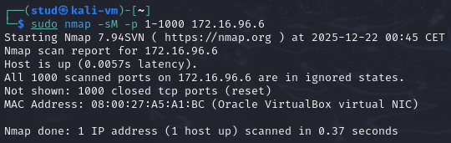
-sA: ACK probe (needs sudo)
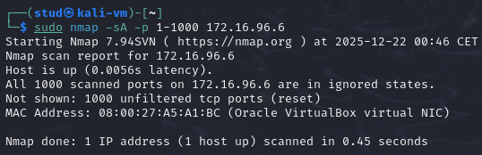
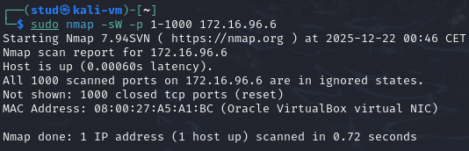
-sW: Window-based ACK (needs sudo)

-sI: Idle (spoofed) (needs sudo) (sudo nmap -sI <zombie_IP> 172.16.96.6 -p 80)
Check for possible zombies: > nmap --script ipidseq 172.16.96.0/24
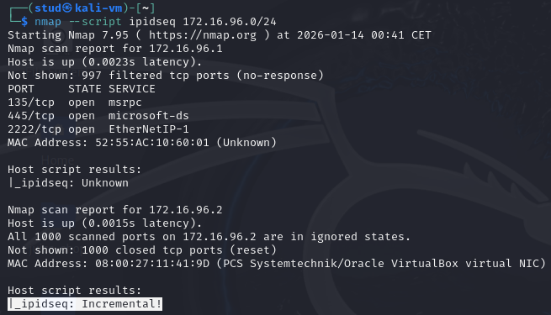

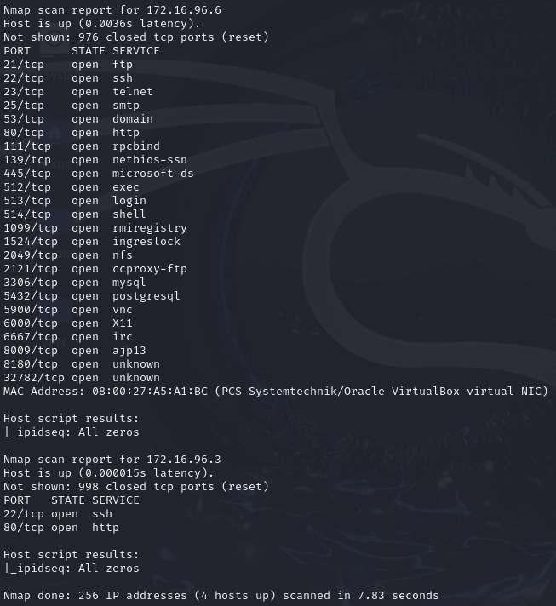
Once a zombie is found (_ipidseq: Incremental): 172.16.96.2
We can use it as a zombie: > nmap -sI 172.16.96.2 -Pn -p 1-1000 172.16.96.6
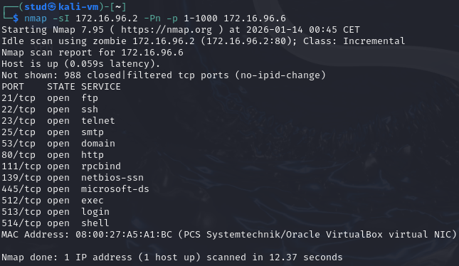
So by using the zombie, Kali’s IP is hidden as all the traffic appears as the zombie.

B. Describe the differences between scanning with aforementioned options
The main differences between the different flags are:
- Accuracy: -sT and -sS are the most reliable for finding open ports.
- Firewall/Filter detection: -sA/-sW are used to detect filtering (filtered vs unfiltered) rather than to find open services.
- Ambiguous results: Flag-based scans (-sN, -sM, etc.) often return open|filtered because no response can mean either open (service silently drops) or packets dropped by firewall.
- Privileges: Most raw-packet scans (-sS, -sN, -sM, -sA, -sW, -sI) require root (sudo). -sT works without root.
- Detectability / forensics: -sT is logged as normal connections; -sS is stealthier but still detectable; -sI hides your IP if successful; -sN/-sM may bypass naive IDS but are less reliable.
- Environment limits: Modern OSes and VMs often break -sI by randomizing or zeroing the IP ID (as you observed), making idle scans frequently infeasible.

Execute UDP scan
We must run: > sudo nmap -sU <target-ip>, all 1000 principal ports are open|filtered
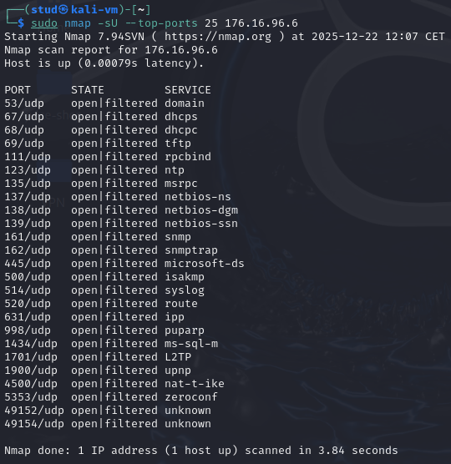
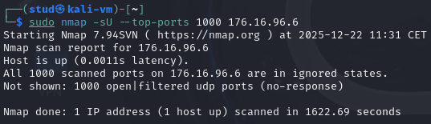

Try different nmap timing options (-T) from a set of values 0,1,2,3,4,5. What is the difference in results and performance?
> time sudo nmap -sU --top-ports 100 -T0 --reason 176.16.96.6:
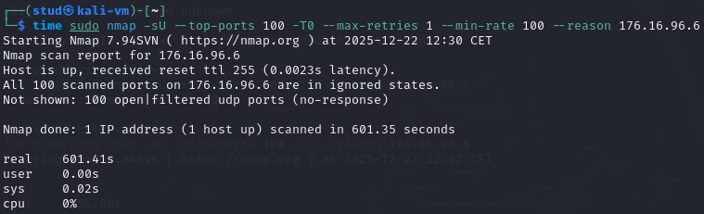
> time sudo nmap -sU --top-ports 100 -T1 --reason 176.16.96.6
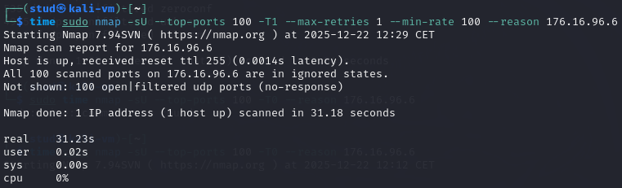
> time sudo nmap -sU --top-ports 100 -T2 --reason 176.16.96.6
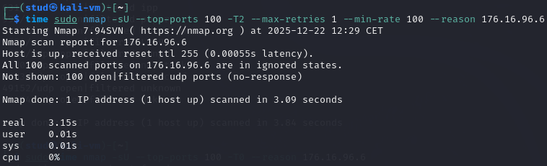
> time sudo nmap -sU --top-ports 100 -T3 --reason 176.16.96.6
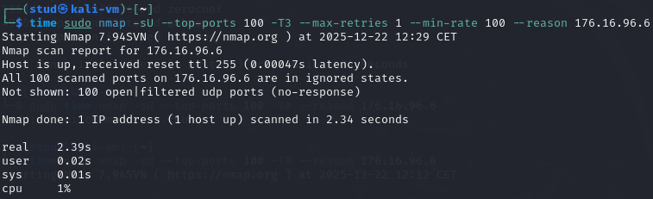
> time sudo nmap -sU --top-ports 100 -T4 --reason 176.16.96.6
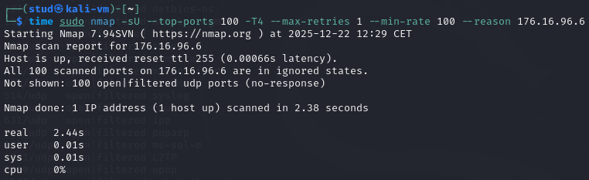
> time sudo nmap -sU --top-ports 100 -T5 --reason 176.16.96.6
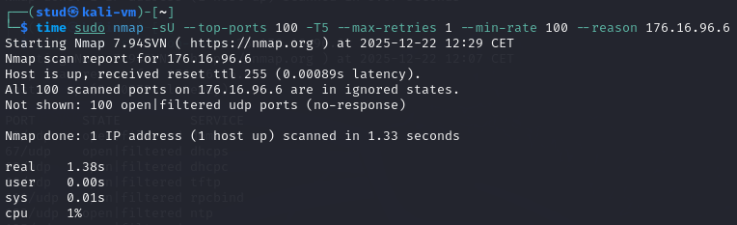
Across all runs the results were the same. Nmap reported all 100 UDP ports as open|filtered (no-response). Performance varied dramatically: -T5 finished in ~1.4s, -T4/T3 ~2.4s, -T2 ~3.1s, -T1 ~31s and -T0 ~601s. This is because higher -T values use much shorter timeouts, higher parallelism and fewer retries (so Nmap gives up faster), while lower -T values wait longer and retry more (slower but more likely to catch delayed or rate-limited ICMP replies).
open|filtered simply indicates no response was seen, not that the port is confirmed open.

For selected system and selected service use service version detection (-sV) eg. > nmap -sV 172.16.96.x -p 22
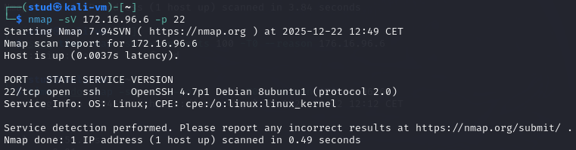
The machine is Linux and exposes an old OpenSSH server on port 22.

Try to discover operating system version installed on VMs (option –O):
What we can see from the sudo nmap -O 172.16.96.6 output
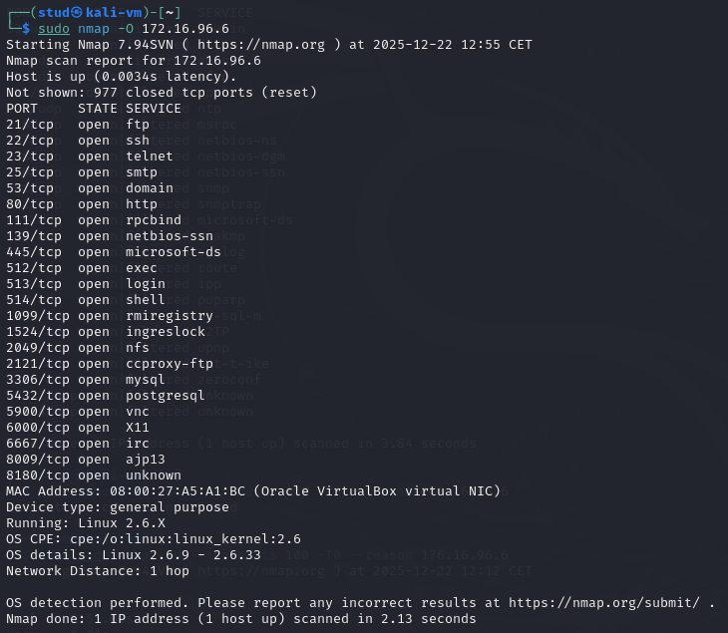
- Many TCP services are open (21, 22, 23, 25, 53, 80, 111, 139, 445, 512–514, 1099, 1524, 2049, 3306, 5432, 5900, 6000, 6667, 8009, 8180, …).
- MAC address 08:00:27:...: Oracle VirtualBox virtual NIC (so this is a VM).
- Device type: general purpose and OS guess: Linux 2.6.X (detailed range: 2.6.9 - 2.6.33; CPE shows linux kernel 2.6).
- Network Distance: 1 hop what means that host is on the local network (same subnet/VM host).
- Takeaway: the VM runs many legacy services (telnet, rsh/rlogin, ftp, old DBs, VNC, X11, SMB, NFS, etc.), these are commonly insecure/outdated and good targets for lab testing.

Check the directory /usr/share/nmap/scripts and find a few various nmap scripts and describe their application:
A. Execute nmap -sC 172.16.96.x (change the IP address)
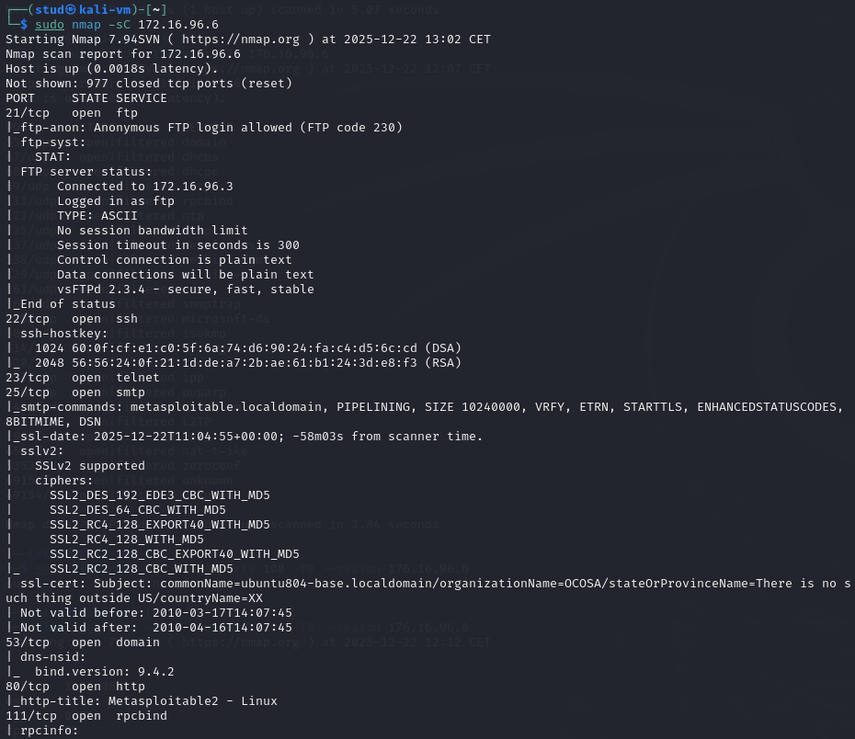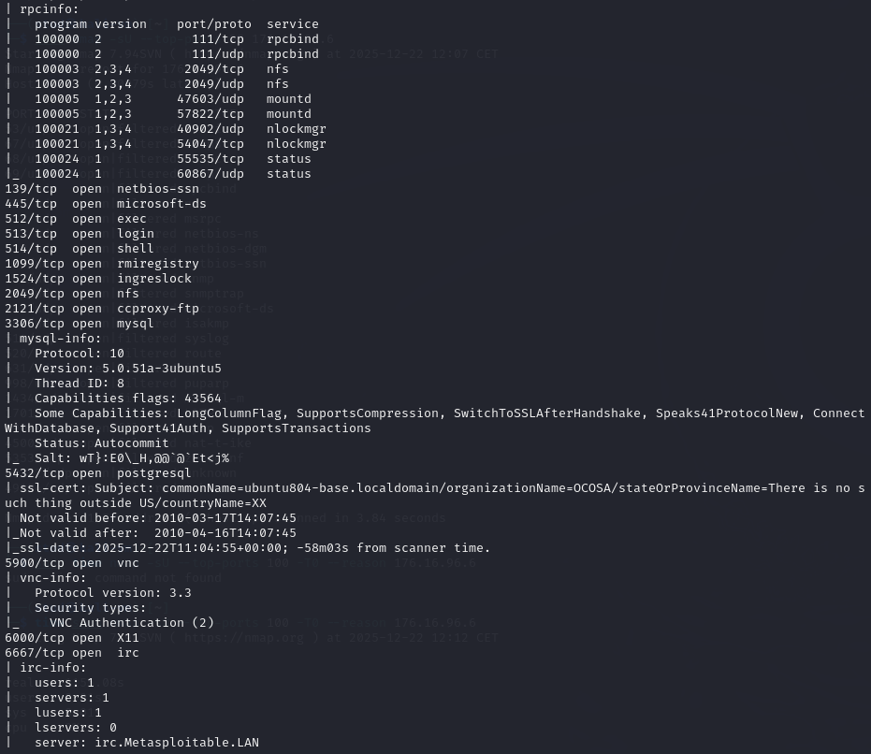
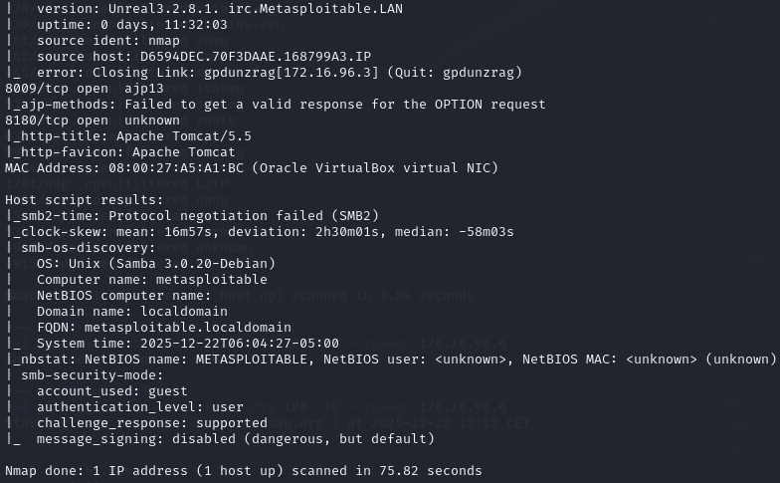

B. Execute nmap --script http-enum,http-headers,http-methods,http-phpversion
Running: > sudo nmap -p 80,8180 -sV --script=http-enum,http-headers,http-methods,http-php-version --reason 172.16.96.6
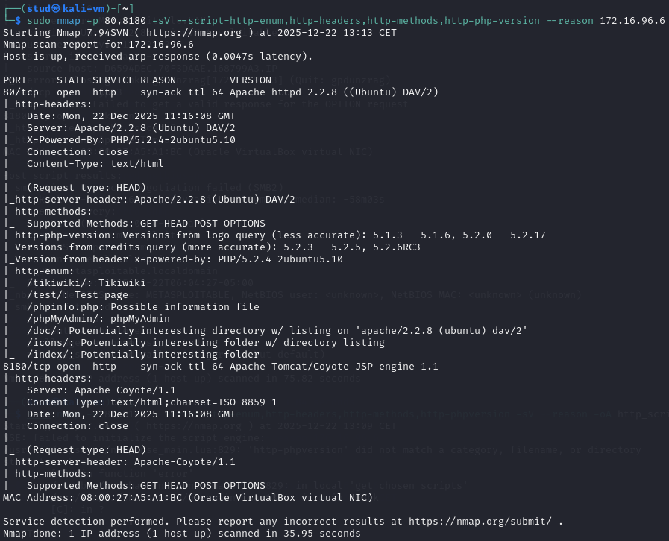
Scans show two HTTP services and several clear weaknesses: port 80 is Apache 2.2.8 (Ubuntu) serving PHP 5.2.4-2ubuntu5.10 (old, EOL and likely vulnerable); http-enum found /phpMyAdmin, /phpinfo.php, /tikiwiki/ and directories with likely listings (/doc, /icons), phpinfo.php can leak config and phpMyAdmin is a high-value attack surface. http-methods shows only GET, HEAD, POST, OPTIONS (no risky PUT/DELETE), but the server and PHP versions are the main risk. Port 8180 runs Apache Tomcat/Coyote 1.1 (also outdated). Combined with the earlier full-host scan (telnet, ftp anonymous, old MySQL/Postgres, VNC, rsh/login services, Linux 2.6 kernel, VirtualBox MAC), this VM is intentionally vulnerable and a good target for lab exploitation.

Use Zenmap to discover the Virtual Network structure and VMs operating systems and active services
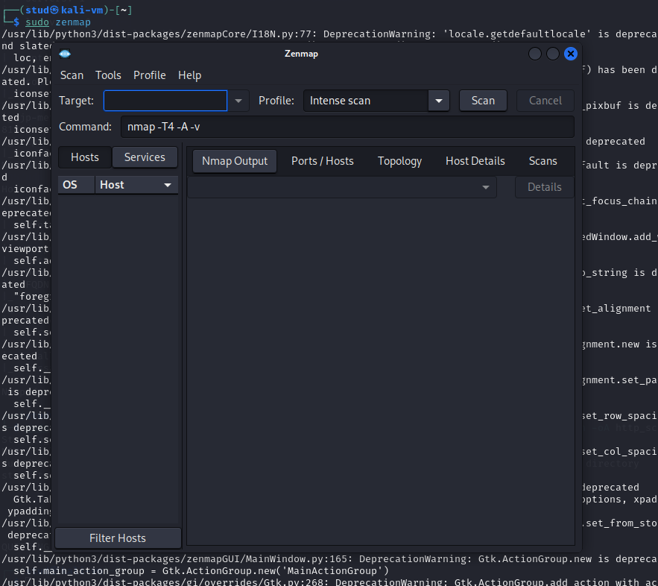
By installing and running: > sudo zenmap

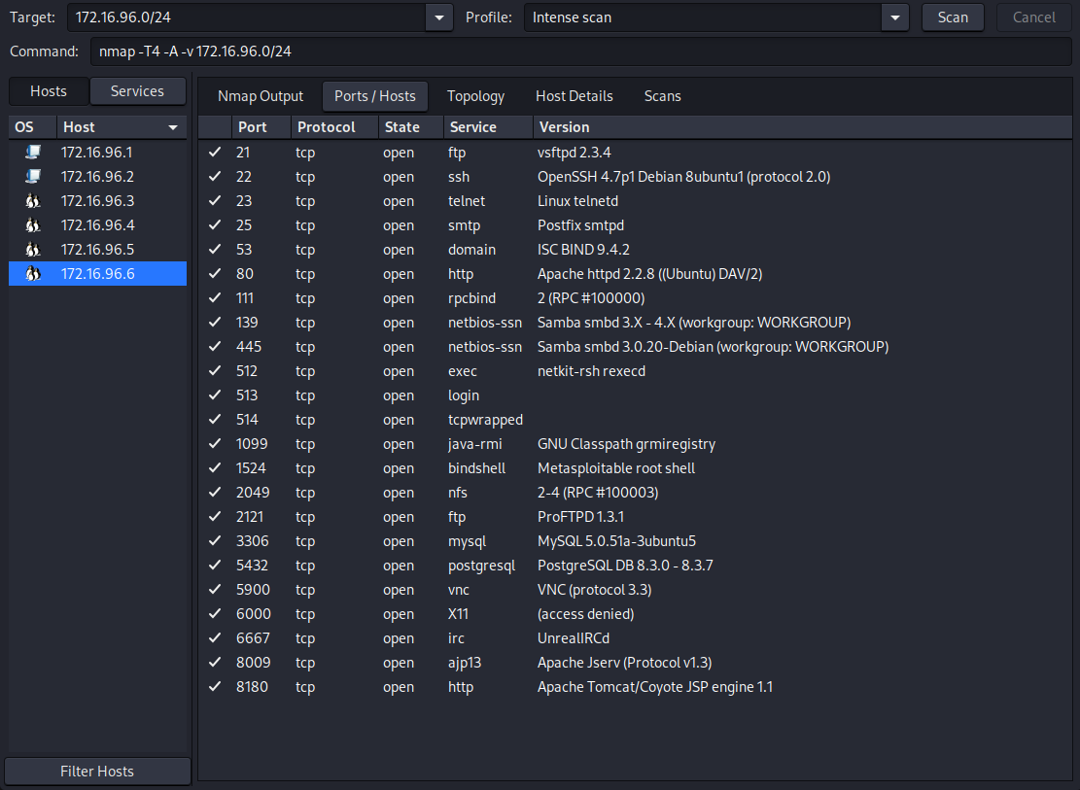
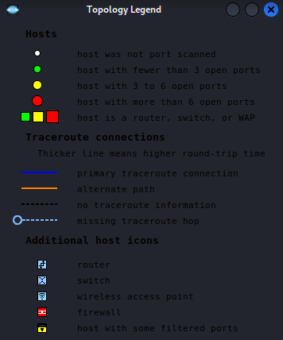
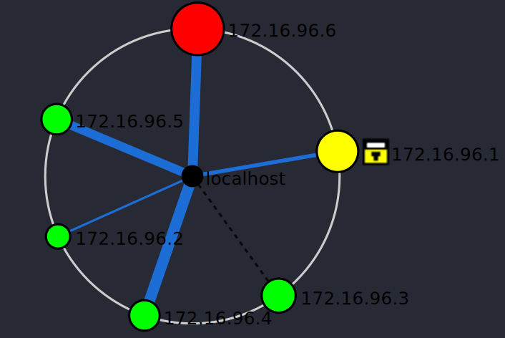
By running the scan with target: > 172.16.96.0/24
You can check all the ports open per device in the network in a visual way.

Use amap tool against selected VM and compare the results with those obtained during nmap scan > amap -bq 172.16.96.x 80 3306

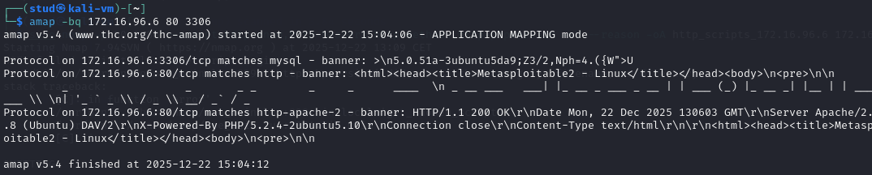
amap v5.4 (www.thc.org/thc-amap) started at 2025-12-22 15:04:06 - APPLICATION MAPPING mode

Protocol on 172.16.96.6:3306/tcp matches mysql - banner: >\n5.0.51a-3ubuntu5da9;Z3/2,Nph=4.({W">U
Protocol on 172.16.96.6:80/tcp matches http - banner: <html><head><title>Metasploitable2 - Linux</title></head><body>\n<pre>\n\n _ _ _ _ _ _ ____ \n _ __ ___ ___| |_ __ _ ___ _ __ | | ___ (_) |_ __ _| |__ | | ______ \\ \n| '_ ` _ \\ / _ \\ __/ _` / _
Protocol on 172.16.96.6:80/tcp matches http-apache-2 - banner: HTTP/1.1 200 OK\r\nDate Mon, 22 Dec 2025 130603 GMT\r\nServer Apache/2..8 (Ubuntu) DAV/2\r\nX-Powered-By PHP/5.2.4-2ubuntu5.10\r\nConnection close\r\nContent-Type text/html\r\n\r\n<html><head><title>Metaspoitable2 - Linux</title></head><body>\n<pre>\n\n

amap v5.4 finished at 2025-12-22 15:04:12

Nmap previously detected port 80 as Apache 2.2.8 (Ubuntu) with PHP 5.2.4 and port 3306 as MySQL, using service/version fingerprinting (-sV). Both tools agree on the services and versions, but amap provides raw protocol banners and application-level fingerprints, while nmap provides structured service/version detection and OS context. This shows that amap complements nmap by confirming services through banner analysis, whereas nmap gives broader and more precise reconnaissance results.

